课程教学进度计划表

一、基本信息

|  |  |  |  |  |  |
| --- | --- | --- | --- | --- | --- |
| 课程名称 | 商务导论 | | | | |
| 课程代码 | 2020590 | 课程序号 | 2236 | 课程学分/学时 | 2/32 |
| 授课教师 | 李艳 | 教师工号 | 21123 | 专/兼职 | 专 |
| 上课班级 | 商英24-1 | 班级人数 | 30 | 上课教室 | 1教314 |
| 答疑安排 | 周一下午：3:00-4:30； | | | | |
| 课程号/课程网站 | https://www.mosoteach.cn/web | | | | |
| 选用教材 | 《商务导论英语教程》，袁奇，清华大学出版社， 2022 | | | | |
| 参考教材与资料 | 1.王艳艳等,《国际商务导论》，外语教学与研究出版社，2013.  2.Understanding Business，William G. Nickels；James M. McHugh；Susan M. McHugh. Tsinghua university press, 2021. | | | | |

二、课程教学进度安排

|  |  |  |  |  |
| --- | --- | --- | --- | --- |
| 课次 | 课时 | 教学内容 | 教学方式 | 作业 |
| 1 | 2 | 第一单元 Business Environment | Lecture, Discussion, Practice & Case study | Review the key points of this lecture; Do the related exercises in the book; Preview next unit. |
| 2 | 2 | 第二单元 Entrepreneurship | Lecture, Discussion, Practice & Case study | Review the key points of this lecture; Do the related exercises in the book; Preview next unit. |
| 3 | 2 | 第三单元 Discovering Business Opportunities | Lecture, Discussion, Practice & Case study | Review the key points of this lecture; Do the related exercises in the book; Preview next unit. |
| 4 | 2 | 第四单元 Establishing a Business | Lecture, Discussion, Practice & Case study | Review the key points of this lecture; Do the related exercises in the book; Preview next unit. |
| 5 | 2 | 第五单元 Organizational Structure | Lecture, Discussion, Practice & Case study | Review the key points of this lecture; Do the related exercises in the book; Preview next unit. |
| 6 | 2 | 第六单元 Recruiting and Training Employees | Lecture, Discussion, Practice & Case study | Review the key points of this lecture; Do the related exercises in the book; Preview next unit. |
| 7 | 2 | 第七单元 Employee Motivation | Lecture, Discussion, Practice & Case study | Review the key points of this lecture; Do the related exercises in the book; Preview next unit. |
| 8 | 2 | 第八单元 Corporate Culture | Lecture, Discussion, Practice & Case study | Review the key points of this lecture; Do the related exercises in the book; Preview next unit. |
| 9 | 2 | 第九单元Production and Product | Lecture, Discussion, Practice & Case study | Review the key points of this lecture; Do the related exercises in the book; Preview next unit. |
| 10 | 2 | 第十单元 Marketing | Lecture, Discussion, Practice & Case study | Review the key points of this lecture; Do the related exercises in the book; Preview next unit. |
| 11 | 2 | 第十一单元Financial Management | Lecture, Discussion, Practice & Case study | Review the key points of this lecture; Do the related exercises in the book; Preview next unit. |
| 12 | 2 | 第十二单元Financing | Lecture, Discussion, Practice & Case study | Review the key points of this lecture; Do the related exercises in the book; Preview next unit. |
| 13 | 2 | 第十三单元CSR | Lecture, Discussion, Practice & Case study | Review the key points of this lecture; Do the related exercises in the book; Preview next unit. |
| 14 | 2 | 第十四单元Going to the International Market | Lecture, Discussion, Practice & Case study | Review the key points of this lecture; Do the related exercises in the book; Preview next unit. |
| 15 | 2 | 第十五单元E-business | Lecture, Discussion, Practice & Case study | Review the key points of this lecture; Do the related exercises in the book; Preview next unit. |
| 16 | 2 | 第十六单元Revision and Report | Discussion, Practice & Case study，Q&A | Revision |

三、考核方式

|  |  |  |
| --- | --- | --- |
| 总评构成 | 占比 | 考核方式 |
| 1 | 50% | 笔试（闭卷） |
| X1 | 10% | 阶段性测试 |
| X2 | 20% | 项目汇报 |
| X3 | 20% | 实践报告 |

任课教师： 电子签名1 ivy（签名） 系主任审核： 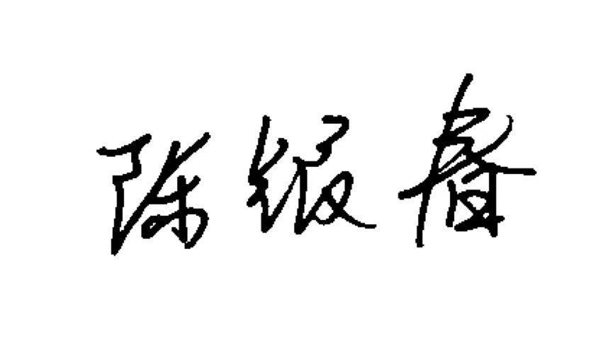 （签名）日期：2024.09.09