上海建桥学院课程教学进度计划表

**一、基本信息Basic information**

|  |  |  |  |
| --- | --- | --- | --- |
| 课程代码 |  | 课程名称 | Oral English 1 |
| 课程学分 | 2 | 总学时 | 32 |
| 授课教师Teacher’s name | Nancy Germano Cunha | 教师邮箱 Email address | [nancy.cunha@outlook.com](mailto:nancy.cunha@outlook.com) |
| 上课班级Name of Classes | Oral English 1 | 上课教室 Classrooms |  |
| 答疑时  Time and place for Q&A | Wednesdays 17:00 - 18:30 IELTS room 221 | | |
| 主要教材Textbook | Say It Right / Shanghai Foreign Education Press | | |
| 参考资料Reference book | Teachers’ own resources. British council resources. Film English. Videos. TedTalk | | |

**二、课程教学进度 Teaching schedule for 16 weeks**

|  |  |  |  |
| --- | --- | --- | --- |
| 周次weeks | 教学内容Teaching Content | 教学方式Teaching method | 作业Homework/Home assignments |
| 1 | Meeting New Friends | video/speaking/reading aloud/ pair work/group task/evaluating | Finish task on page 11 with classmates |
| 2 | Schedules and Appointments | speaking/reading aloud/ pair work/group task/linking words/evaluating | Finish task on page 21 with classmates |
| 3 | Interview | speaking/reading aloud/ getting acquainted with business meetings/pair work/group task/linking words/evaluating | Finish task on page 31 with classmates |
| 4 | Seeing a Doctor | Video/speaking/reading aloud/ letter exchange/pair work/group task/linking words/evaluating | Finish task on page 41 with classmates |
| 5 | Meals and Restaurants | Practice poem/speaking/reading aloud/ word game/pair work/group task/linking words/evaluating | Finish task on page 52 with classmates |
| 6 | Shopping | speaking/reading aloud/ pair work/group task/linking words/evaluating | Finish task on page 61 with classmates |
| 7 | Housing | speaking/reading aloud/ role play/pair work/group task/linking words/evaluating | Finish task on page 72 with classmates |
| 8 | Telephone | speaking/reading aloud/ pair work/group task/linking words/evaluating | Finish task on page 81 with classmates |
| 9 | Oral practice | Role play/speaking/reading aloud/ sing a song/ pair work/group task/linking words/evaluating | Finish task on page 89 with classmates |
| 10 | Sports | speaking/reading aloud/ pair work/group task/linking words/evaluating | Finish task on page 99 with classmates |
| 11 | Personal Relationship | reading aloud/ speaking/scramble/ pair work/group task/linking words/evaluating | Finish task on page 111 with classmates |
| 12 | Gift Giving | speaking/reading poem aloud/ role play/pair work/group task/linking words/evaluating | Finish task on page 121 with classmates |
| 13 | Family | Video/speaking/reading poem aloud/ dialogue/pair work/group task/linking words/evaluating | Finish task on page 134 with classmates |
| 14 | Entertainment | speaking/reading poem aloud/ dialogue/pair work/group task/linking words/evaluating | Finish task on page 142 with classmates |
| 15 | Fashion | speaking/reading aloud/ pair work/group task/linking words/evaluating | Finish task on page 153 with classmates |
| 16 | Final week | Final presentation on Independence | Oral |

**八．评价方式与成绩 Ways of Evaluation and Percentages**

|  |  |  |
| --- | --- | --- |
| 总评构成（1+X） | 评价方式 | 占比 |
| 1 | Final Presentation | 55% |
| X1 | Home Assignments | 15% |
| X2 | Pair Work and Group Tasks | 15% |
| X3 | Course Credit Participation | 15% |

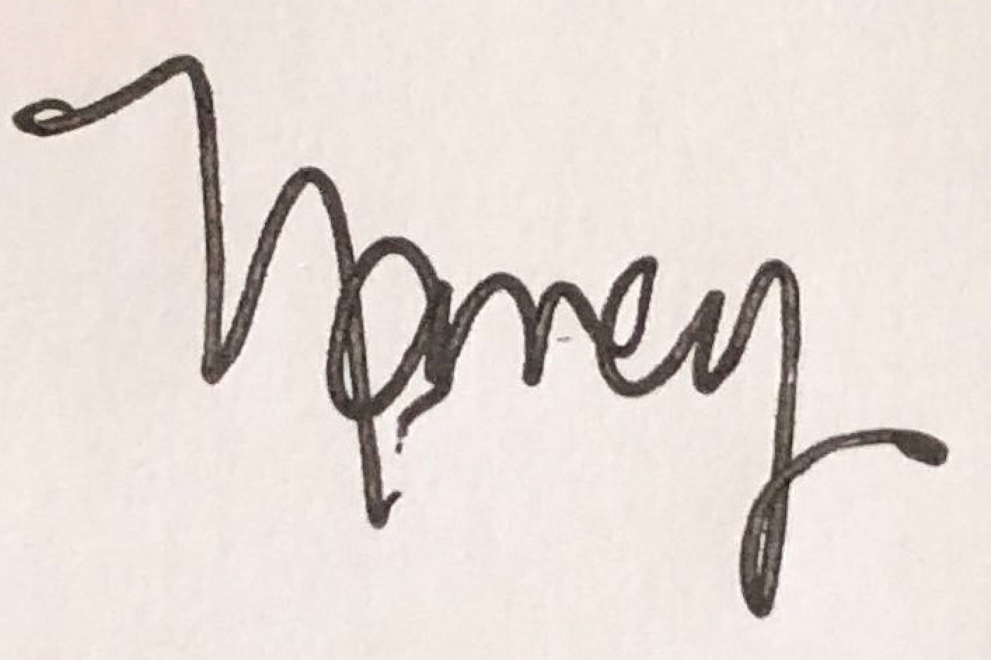 任课教师Instructor’s signature：

系主任审核Dean’s signature：

日期：2023.9