SJQU-QR-JW-013（A0）

上 海 建 桥 学 院
_英美文学选读_课程教案
周次 2 第 2 次课 学时 2 教案设计人 王海燕
章节名称 | Geoffrey Chaucer
授课形式 | 理论课∨ 案例讨论课□ 实验课□ 习题课□ 其他□
本次授课目的与要求Teaching Objectives and Requirements
- The students are required to get the guiding idea of Chaucer’s literary career;
- Understand Chaucer’s representative works;
- Get to know the stylistic features of popular ballads.
本次教学重点与难点Key Points and Difficult Points in Teaching
- Geoffrey Chaucer and His The Canterbury Tales;
- Popular Ballads;
- Robin Hood and Allin-a-Dale.
教学内容提要及时间分配Teaching Content and Time Allotment |  | 教学方法与手段设计
- Teaching Content  1. Historical Background  The Hundred Years’ War：The Hundred Years' War (1337-1453) was a series of armed conflicts, broken intermittently by a number of truces and peace treaties, between England and France. It started from the reign of Edward Ⅲ (1327-1377) to the reign of Henry VI (1421-1471). It resulted from disputes between the ruling families of the two countries over territories in France and the succession of the French throne.  2. Geoffrey Chaucer and the General Prologue of The Canterbury Tales  - Chaucer’s position: He was respected as “father of English poetry” and one of the greatest narrative poets of England.  - Chaucer’s life and works: The Romance of the Rose (translated from French), Troilus and Cressie (adapted from Italian), The Canterbury Tales  - Chaucer’s contribution: Heroic couplet (英雄双韵体): It contains two lines in iambic pentameter with the same end rhyme. (from France). He is the first great poet who wrote in the English language  - The General Prologue is regarded as the greatest portrait gallery in English literature. Ranging in status from a Knight to a humble Plowman, the pilgrims are microcosm of 14th-century English society.  3. Popular Ballads  - The English popular ballads are a part of English folk literature, literature of ordinary people. These ballads flourished from the 12th to the 15th century.  - Robin Hood is partly historical and partly legendary character. Robin Hood ballads show the fighting spirit, indomitable courage and revolutionary energy of the English peasantry. They best exemplified the views of the exploited classes of feudal society.  II. Time Allotment 2 periods  1. Historical backgrounds 0.5 period;  2. Chaucer’s life and works: 1.0 period;  3. Robin Hood and Allin-a-Dale. 0.5 period. |  | Teaching Methods and Means  - Lecture;  - Presentation;  - Multi-media；
课外复习、预习要求及作业布置
1. Discuss the question: How to analyze English poetry?
2. A survey of Shakespeare and his works.
课后反思 | Through the lectures, the students can learn some methods of reading the texts and enjoying the works. By giving the comments, the students’ abilities are improved. However, more practices should be suggested for this is a new course for students.

上 海 建 桥 学 院
_英美文学选读_课程教案
周次 3 第 3 次课 学时 2 教案设计人 王海燕
章节名称 | The Renaissance
授课形式 | 理论课∨ 案例讨论课□ 实验课□ 习题课□ 其他□
本次授课目的与要求Teaching Objectives and Requirements
1. Improve students’ realization of the Renaissance period, one of the most important period in literature prosperity；
2. Get to know more about some literary giants such as Shakespeare, Marlowe and so on;
3.To know about Sonnet 18
本次教学重点与难点Key Points and Difficult Points in Teaching
- The features of Renaissance；
- William Shakespeare and Sonnet 18
- Thematic analysis of “To be or Not to be “
教学内容提要及时间分配Teaching Content and Time Allotment |  | 教学方法与手段设计
I. Teaching Content  - William Shakespeare：As the greatest English poet and dramatist, he left us a great wealth of 154 sonnets, 37 plays, including 14 comedies, 12 tragedies, and 11 historical plays, as well as two long poems.  - The definition of Renaissance: Revival or rebirth of classical arts, culture and philosophy after the dark ages of medieval obscurantism. It’s a great cultural and intellectual movement swept the whole of Europe.  - Shakespeare's sonnets comprise a collection of 154 poems in sonnet form that deal with such themes as love, beauty, politics, and mortality. The sonnets comprise four stanzas of three quatrains and a final couplet composed in iambic pentameter with the rhyme scheme abab cdcd efef gg.  - Sonnet 18, often alternately titled Shall I compare thee to a summer's day?, is one of the best-known of 154 sonnets written by the English playwright and poet William Shakespeare.In the sonnet, the speaker compares his beloved to the summer season, and argues that his beloved is better. He also states that his beloved will live on forever through the words of the poem. Sonnet 18 is written in the typical Shakespearean sonnet form, having 14 lines of iambic pentameter ending in a rhymed couplet. Detailed exegeses have revealed several double meanings within the poem, giving it a greater depth of interpretation.  - Thematic analysis of “To be or Not to be ”  II. Time Allotment 2 periods  1. Historical backgrounds: renaissance 0.5 period;  2. A quick Question -and-Answer activity of Shakespeare and his works 10 min  3. Analysis of Sonnet 18  4. The textual study Hamlet: To be or Not to be 1.0 period; |  | Teaching Methods and Means  - Lecture;  - Q&A  - Acting  - Multi-media
课外复习、预习要求及作业布置
1.Choose one literary works you are interested in and read at least 15 pages each day, and keep reading notes at the same time.
2. Preview Bacon’s works: Of Studies and get ready for in-class discussion on how to read and study.
课后反思 | In order to arouse the students interests of learning Literature and reading literary works, teacher are supposed to involve more students into class activity and language practice, such as performing , acting , discussing, rather than just lecturing.

上 海 建 桥 学 院
_英美文学选读_课程教案
周次 4 第 4 次课 学时 2 教案设计人 王海燕
章节名称 | The Renaissance
授课形式 | 理论课∨ 案例讨论课□ 实验课□ 习题课□ 其他□
本次授课目的与要求Teaching Objectives and Requirements

1.To get to know Bacon and his works
3.To appreciate Bacon’s Essay: Of studies
4. To have a discussion of “ reading”

本次教学重点与难点Key Points and Difficult Points in Teaching
- Bacon’s scientific research method
- Textual analysis of “Of studies”
教学内容提要及时间分配Teaching Content and Time Allotment |  | 教学方法与手段设计
I. Teaching Content  - Introduction of Francis Bacon：  - Life experience and writings  An English philosopher, statesman, scientist, jurist, orator, and author. He served both as Attorney General and as Lord Chancellor of England. After his death, he remained extremely influential through his works, especially as philosophical advocate and practitioner of the scientific method during the scientific revolution.  - Bacon’s scientific research method  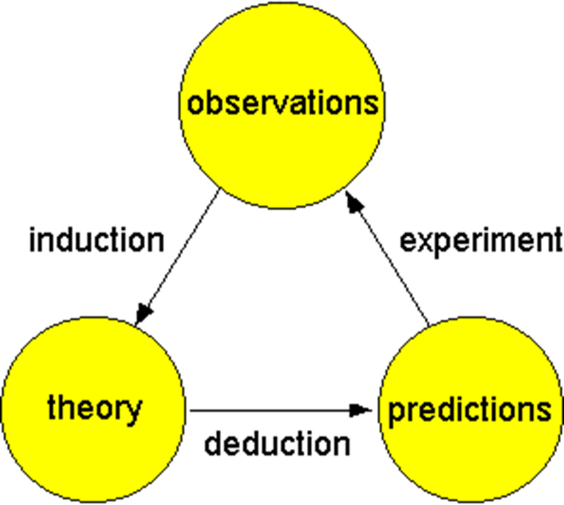  - Francis Bacon’s Essay:  - The first example of that genre in English literature, which has been recognized as an important landmark in the development of English prose.  - Famous for brevity, compactness and powerfulness. And the neatness, the preciseness, the gravity, and the weightiness are the essential qualities of his writings.  - Balance and opposition are the most common strategies used to achieve both the appearance of balance and the concealment of his own opinions under the cloak of the opposing alternatives.  - Theme of “Of Studies”:  - The use and abuse of studies  - The proper and improper ways to pursue one’s studies  - The effect of the different kinds of studies upon human character  4.Writing feature:  - Coherence: Arguments are well arranged in unity and in one paragraph.  - Conciseness of expressions and phrases: a plain style as well as his simple language.  - Simple metaphors: deep implications.  - Omission: makes the essay concise, clear and coherent.  - Parallels: Natural flow, logical, convincingly and forceful.  5. A detailed reading and discussion  - Translating and understanding  - Discussing the topic of reading  II. Time Allotment 2 periods  - Introduction of Bacon:0.5 period  - Writing features of Bacon:0.5 Period  - Textual Analysis of Bacon:0.5 Period  - Discussion: 0.5 period |  | Teaching Methods and Means  - Lecture;  - Q&A  - Acting  - Multi-media  - discussion
课外复习、预习要求及作业布置
- Preview :The background of the period of Revolution and restoration
- John Donne: Death be Not proud

课后反思 | - The discussion topic, viewpoints, ideas and supporting details should be prepared in advance to make the discussion more effective. Meanwhile, more students should be encouraged to be involved in the discussion. TO make this happen, the teacher need to have some guiding questions.

