上 海 建 桥 学 院
《跨文化交际》课程教案
周次 1 第1次课 2 学时 教案撰写人：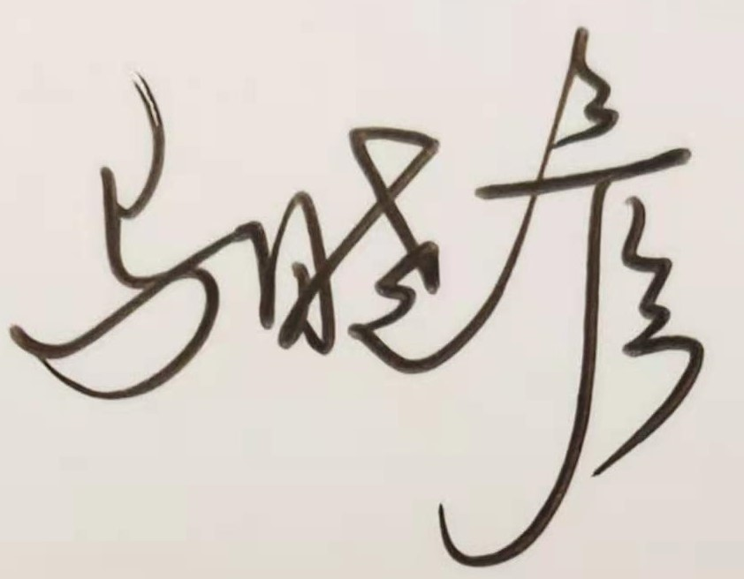 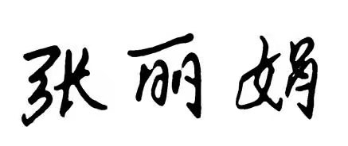
课程单元名称 | 课程介绍
本次授课目的与要求
介绍课程的教学安排内容，进度，学习要求及考核方式等；
布置第一单元自学内容
教学设计思路
介绍展示课程介绍、教学大纲、教学进度安排表、教案等文件；
制作PPT向学生说明学习要求及考核方式，布置第一单元自学内容；
介绍BB平台的使用
本次教学重点与难点
教学进度安排、考核方式、学习要求的解释说明
教学内容提要及时间分配 |  | 教学方法与手段设计
（可添页）  - 课程介绍（10min);  - 教学进度安排、学习要求、考核方式说明（30min)  - 课后作业布置（5min) |  | 面授  多媒体互动  PPT  BB平台课前课后预习及复习  微信群微信互动
课外复习、预习要求及作业布置
- 完成阅读第一单元课文；
- 完成预习作业。
课后反思
SJQU-QR-JW-013（A0）
上 海 建 桥 学 院
《跨文化交际》课程教案
周次 2 第2次课 2 学时 教案撰写人：
课程单元名称 | Chapter 1 What is culture?
本次授课目的与要求
On completion of this chapter, students should be able to:
1. Understand the definitions of culture.
2. Describe the functions and characteristics of culture.
3. Summarize the process of the formation of cultural identity.
4. Evaluate cultural diversity.
教学设计思路
Start with an oral presentation about one cultural difference between China and some English-speaking country, have a group discussion about the questions of cultural identity and cultural diversity and make a case study.

本次教学重点与难点
Cultural identity
教学内容提要及时间分配 |  | 教学方法与手段设计
（可添页）  Lead-in – 5mins  Warm-up Question: What is culture? How do you define ‘culture’?  Presentation – 40mins  Discussion about cultural identity and its process of formation (15min);  Discussion and evaluation of cultural diversity(15min);  Case study (10min) |  | Multi-media  Discussion;  Question & Answer;
课外复习、预习要求及作业布置
Assignment：
- Work out the definitions of cultural identity, subculture, co-culture and subgroup;
- Finish the Exercise 1 & 2 of Assessment,Chapter 1
- Answer the questions provided in PPT;
- Preview the next chapter.

课后反思

上 海 建 桥 学 院
《跨文化交际》课程教案
周次 3 第3次课 2 学时 教案撰写人：
课程单元名称 | Chapter 2 Communication and intercultural communication
本次授课目的与要求
On completion of this chapter, students should be able to:
1. Understand the definition and components of communication.
2. Describe the characteristics of communication.
3. Summarize the definition of intercultural communication.
4. Evaluate the forms of intercultural communication.
教学设计思路
Start with an oral presentation about one cultural difference between China and some English-speaking country, have a group discussion about the questions of cultural identity and cultural diversity and make a case study.

本次教学重点与难点
Intercultural communication and its forms
教学内容提要及时间分配 |  | 教学方法与手段设计
（可添页）  Lead-in – 5mins  Warm-up Question: What is communication? What does communication consist of?  Presentation – 40mins  Discussion about the definition of communication and its components(10min);  Discussion about the characteristics of communication(10min);  Discussion about the definition of intercultural communication and its forms(10min);  Discussion about the relationship between culture and communication (10min); |  | Question & Answer;  Discussion;  Multi-media
课外复习、预习要求及作业布置
Assignment：
- Work out the definitions of cultural identity, subculture, co-culture and subgroup;
- Finish the Exercise 1 & 2 of Assessment,Chapter 2
- Answer the questions provided in PPT;
- Preview the next chapter.

课后反思

