SJQU-QR-JW-013（A0）
上 海 建 桥 学 院
《英语阅读（2）》课程教案
周次 1 第1次课 2学时 教案撰写人 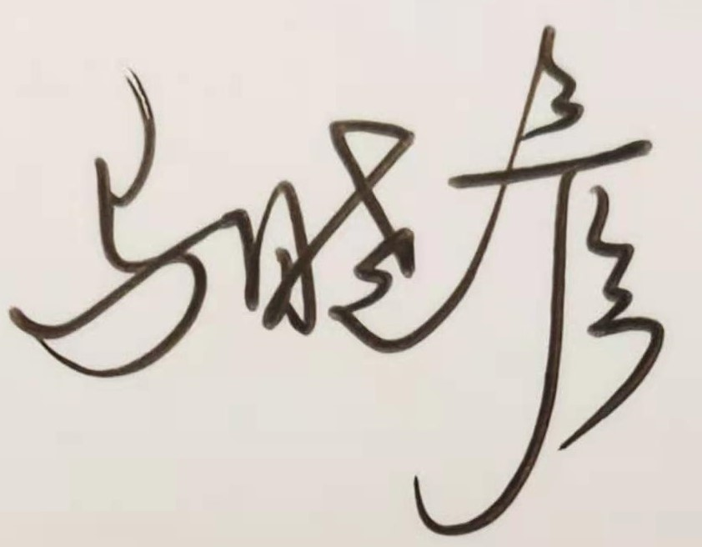
课程单元名称 | Course Introduction & Test Briefing
本次授课目的与要求
让学生了解课程内容及考核方式，以及学习本门课程的注意事项。

教学设计思路
第一部分：介绍课程内容、目标、教学进度以及学习建议，让学生了解本课程基本安排，从而能开展更加有效地学习。
第二部分：介绍学习方式；
第三部分：布置课后作业

本次教学重点与难点
重点：课程考核方式
难点：掌握学习方法，保证学习效果。
教学内容提要及时间分配 |  | 教学方法与手段设计
- 课程介绍 （15min）;  - 教学进度安排；  - 考核方式  - 学习方式（15min）  - 互动联系方式  - 上课资料获取方式  - 如何利用BB平台学习建议  - 布置课后作业(15min)  - 作业内容及格式要求  - 作业上交方式 |  | 面授  多媒体互动  PPT  BB平台课前课后预习及复习  微信群微信互动
课外复习、预习要求及作业布置

- 下载BB平台课后作业单及第一单元PPT；
- 预习第一单元Text 1，完成重点词汇学习
课后反思

上 海 建 桥 学 院
《英语阅读（2）》课程教案
周次 2 第2次课 2学时 教案撰写人
课程单元名称 | Unit 1 The Shadowland of Dreams （1）
本次授课目的与要求
After the completion of this period, students are supposed to
- understand the real meaning of writing
- understand the hardship for Alex Haley to be successful
- learn about ways of going through hard times

教学设计思路

Step 1: Pre-reading discussion
Step 2: Background Information
Step 3: Text Analysis
Step 4: Key words Explanation

本次教学重点与难点

Focus:
What’s the main idea of the story？
What’s the difference between “being a writer” and writing according to Haley?
How did Haley become successful step by step?
What lessons did Haley learn from his own experiences?

教学内容提要及时间分配 |  | 教学方法与手段设计
- Lead-in Discussion (5min)  - Background Information (10mins)  - Text Analysis (30min)  - Assignment (5min) |  | 面授  多媒体互动  PPT  BB平台课前课后预习及复习  微信群微信互动
课外复习、预习要求及作业布置
作业：3篇fast reading 与1篇home reading
预习：预习重点词汇
课后反思

上 海 建 桥 学 院
《英语阅读（2）》课程教案
周次 3 第3次课 2 学时 教案撰写人
课程单元名称 | Unit 1 The Shadowland of Dreams （2）
本次授课目的与要求
After the completion of thisperiod, students are supposed to :
- Understand the meanings and usage of keys words;
- Understand the meaning of some long sentences;
- Be able to use dictionary to learn new words
教学设计思路

Step 1: Explain Key words involved in Text
Step 2: Analyse sentence structure of long sentences;
Step 3: Suggest how to use English dictionary
本次教学重点与难点

Word Focus: resolution,genuine,sacrifice,veteran,plunge,tempt,crumbled,a morsel of, do …on the side,well up
Key sentences:
In most cases these individuals are dreaming of wealth and fame, not the long hours alone at a tyepwriter. “you’ve got to want to write,” I say to them, “not want to be a writer.”
This is the Shadowland of hope, and anyone with a dream must learn to live there.
教学内容提要及时间分配 |  | 教学方法与手段设计
- Warm-up Exercise (5mins)  - Key Words Explanation (15mins)  - Long Sentences Analysis (15mins)  - Reading Skills (5 mins)  - Assignment (5mins) |  | 面授  多媒体互动  PPT  BB平台课前课后预习及复习  微信群微信互动
课外复习、预习要求及作业布置
课后作业: 自习Unit1 阅读技巧部分（如何利用字典），完成作业单上的词汇练习
预习: unit 2
课后反思
上 海 建 桥 学 院
《英语阅读（2）》课程教案
周次 4 第4次课 2学时 教案撰写人
课程单元名称 | Unit 2 Critical Thinking（1）
本次授课目的与要求
After the completion of this period, students are supposed to
- understand what is critical thinking
- learn how to think critically
- learn some “happy accidents” in the history of scientific inquiry

教学设计思路

Step 1: Pre-reading discussion
Step 2: Background Information
Step 3: Text Analysis
Step 4: Key words Explanation

本次教学重点与难点

Focus:
- What are the definitions of critical thinking?
- What is the task for us according to the writer? Why?
- What are the barriers to critical thinking? How to overcome them?
- What are the standards to assess critical thinking?
- What conclusion can be drawn from the text? Why?

教学内容提要及时间分配 |  | 教学方法与手段设计
- Lead-in Discussion (5min)  - Background Information (10mins)  - Text Analysis (30min)  - Assignment (5min) |  | 面授  多媒体互动  PPT  BB平台课前课后预习及复习  微信群微信互动
课外复习、预习要求及作业布置
作业：3篇fast reading 与1篇home reading
预习：预习重点词汇
课后反思

上 海 建 桥 学 院
《英语阅读（2）》课程教案
周次 5 第5次课 2 学时 教案撰写人
课程单元名称 | Unit 2 Critical Thinking（2）
本次授课目的与要求
After the completion of thisperiod, students are supposed to :
- Understand the meanings and usage of keys words;
- Understand the meaning of some long sentences;
- learn how to deal with synonyms and antonyms
教学设计思路

Step 1: Explain Key words involved in Text
Step 2: Analyse sentence structure of long sentences;
Step 3: Suggest the methods to deal with synonyms and antonyms
本次教学重点与难点

Word Focus: assess; access ; confine; undermine; barrier; obstacle; routine; ethics; conceive; transform
transcend; encompass; overlap; swallow up ; far from; dysfunctional; malpractice; egocentricity

Key sentences:
Thus, critical thinking requires you to work on your thinking continually, to make your thinking the object of thought; to make your behavior the object of your thinking; to make your beliefs the object of your thinking.

教学内容提要及时间分配 |  | 教学方法与手段设计
- Warm-up Exercise (5mins)  - Key Words Explanation (15mins)  - Long Sentences Analysis (15mins)  - Reading Skills (5 mins)  - Assignment (5mins) |  | 面授  多媒体互动  PPT  BB平台课前课后预习及复习  微信群微信互动
课外复习、预习要求及作业布置
课后作业: 自习Unit2 阅读技巧部分（近义词和反义词），完成作业单上的词汇练习
预习: unit 3
课后反思
上 海 建 桥 学 院
《英语阅读（2）》课程教案
周次 6 第6次课 2学时 教案撰写人 马晓彦
课程单元名称 | Unit 3 Recycling（1）
本次授课目的与要求
After the completion of this period, students are supposed to
- learn about waste recycling
- understand the environmental problems better
- understand global warming
教学设计思路

Step 1: Pre-reading discussion
Step 2: Background Information
Step 3: Text Analysis
Step 4: Key words Explanation

本次教学重点与难点

Focus:
- Why is recycling one of the best environmental success stories of the late 20th century?
- Is recycling worth all the effort?
- What different attitudes do people have toward recycling?
- Is recycling a fad or a new idea? How has recycling developed?
- How will recycling develop in the USA? Why?

教学内容提要及时间分配 |  | 教学方法与手段设计
- Lead-in Discussion (5min)  - Background Information (10mins)  - Text Analysis (30min)  - Assignment (5min) |  | 面授  多媒体互动  PPT  BB平台课前课后预习及复习  微信群微信互动
课外复习、预习要求及作业布置
作业：3篇fast reading 与1篇home reading
预习：预习重点词汇
课后反思

